05-03-2021
INTERNS TRAINING PROGRAMME
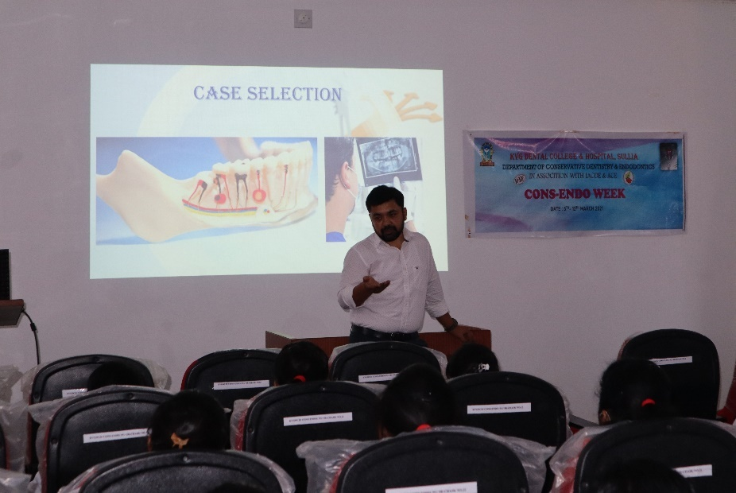
LECTURE BY DR NAVEEN KUMAR
08-03-2021
INTERNS TRAINING PROGRAMME
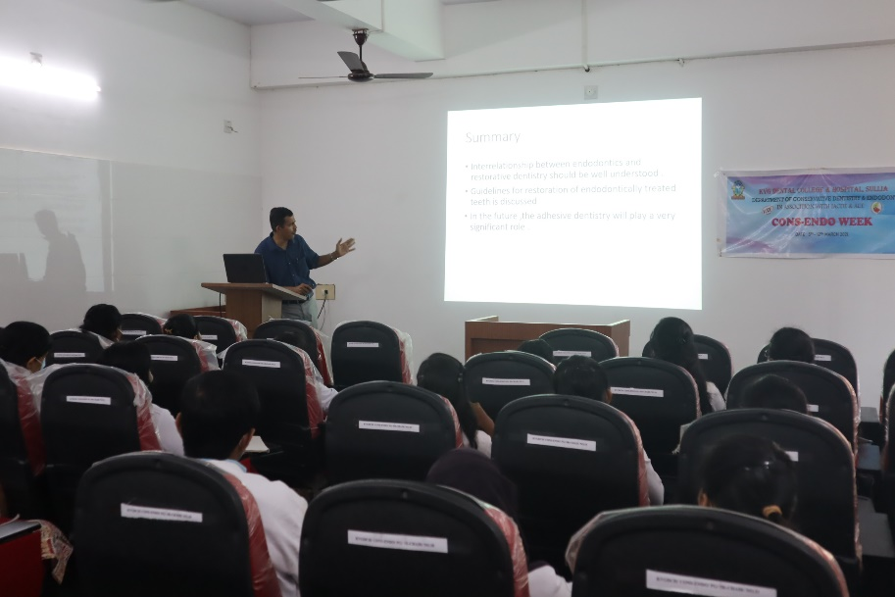
LECTURE BY DR KRISHNA PRASADA L

12-03-2021
INTERNS TRAINING PROGRAMME
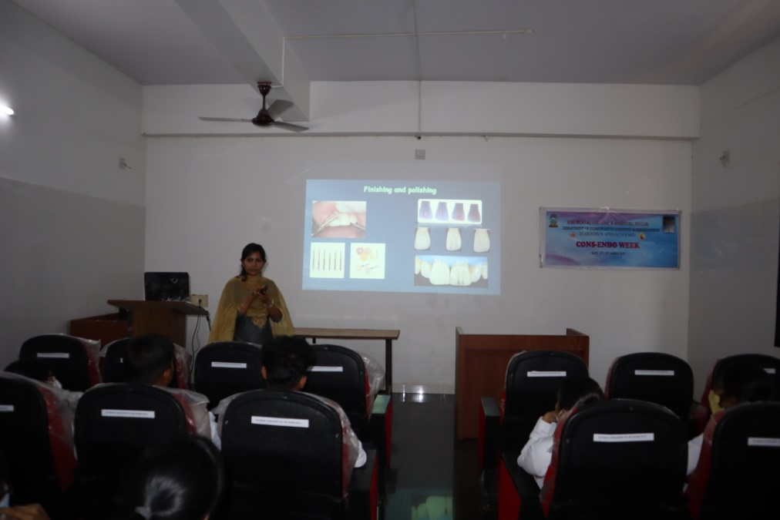
LECTURE BY DR RAMYA

